LAB EXPERIMENT RECORD
SET 4: PRODUCT INVENTORY MANAGEMENT
Department | AIDS
Course Code / Course Name | DSA0601 / Data Handling and Visualization
Experiment | Data Visualization using R
Name | B. Pallavi
Register Number | 192424243
Date | 01 October 2026
Day | Thrusday

Aim
To visualize product inventory data using a bar chart, stacked bar chart, and scatter plot, and to build an interactive dashboard using R and Tableau.
Dataset: Product Inventory
Product ID | Product Name | Quantity Available
1 | Product A | 250
2 | Product B | 175
3 | Product C | 300
4 | Product D | 200
5 | Product E | 220
PROGRAM 1: Bar Chart of Product Inventory
Create a bar chart to visualize the quantity available for each product. Label the axes and title the chart appropriately.
# Dataset
product <- c("Product A", "Product B", "Product C",
"Product D", "Product E")

quantity <- c(250, 175, 300, 200, 220)

# Bar Chart
barplot(quantity,
names.arg = product,
xlab = "Product",
ylab = "Quantity Available",
main = "Product Inventory",
col = "skyblue")
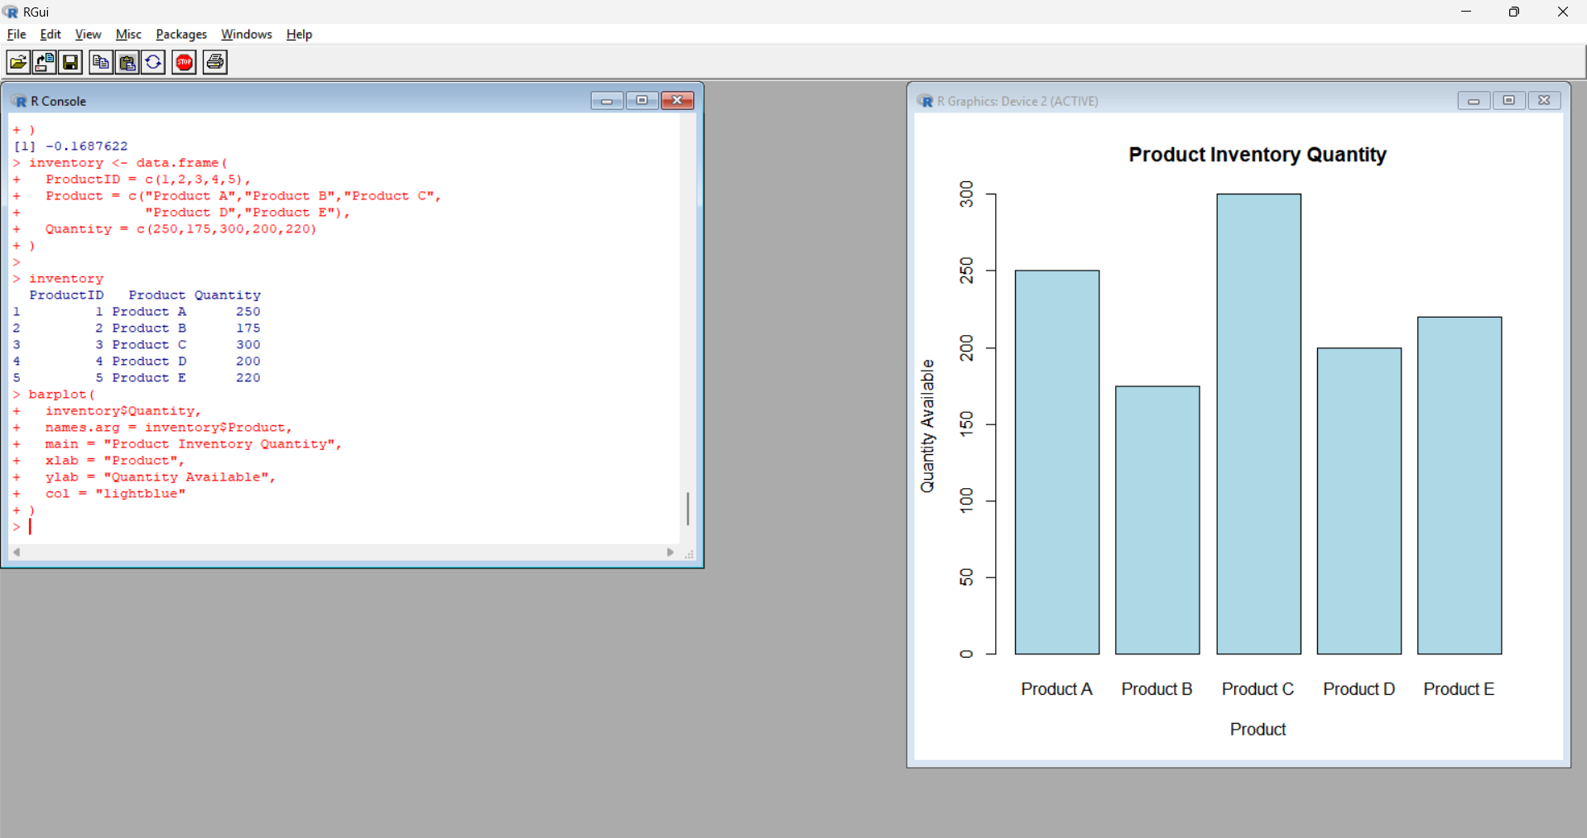
Output 1: Product Inventory Bar Chart
Observation: The bar chart makes it easy to compare the inventory quantity of each product. Product C has the highest quantity of 300, while Product B has the lowest quantity of 175.
PROGRAM 2: Stacked Bar Chart by Product Category
Create a stacked bar chart to visualize the distribution of product inventory according to product categories.
Note: The given dataset contains only Product ID, Product Name, and Quantity. Therefore, the following category values are used as sample values.
Product | Category | Quantity
Product A | Electronics | 250
Product B | Electronics | 175
Product C | Home | 300
Product D | Home | 200
Product E | Accessories | 220
# Dataset
product <- c("Product A", "Product B", "Product C",
"Product D", "Product E")

quantity <- c(250, 175, 300, 200, 220)

category <- c("Electronics",
"Electronics",
"Home",
"Home",
"Accessories")

# Create table
inventory_data <- table(category, product)

# Stacked Bar Chart
barplot(inventory_data,
beside = FALSE,
main = "Inventory by Product Category",
xlab = "Product",
ylab = "Quantity Available",
legend.text = TRUE,
col = c("skyblue", "lightgreen", "orange"))
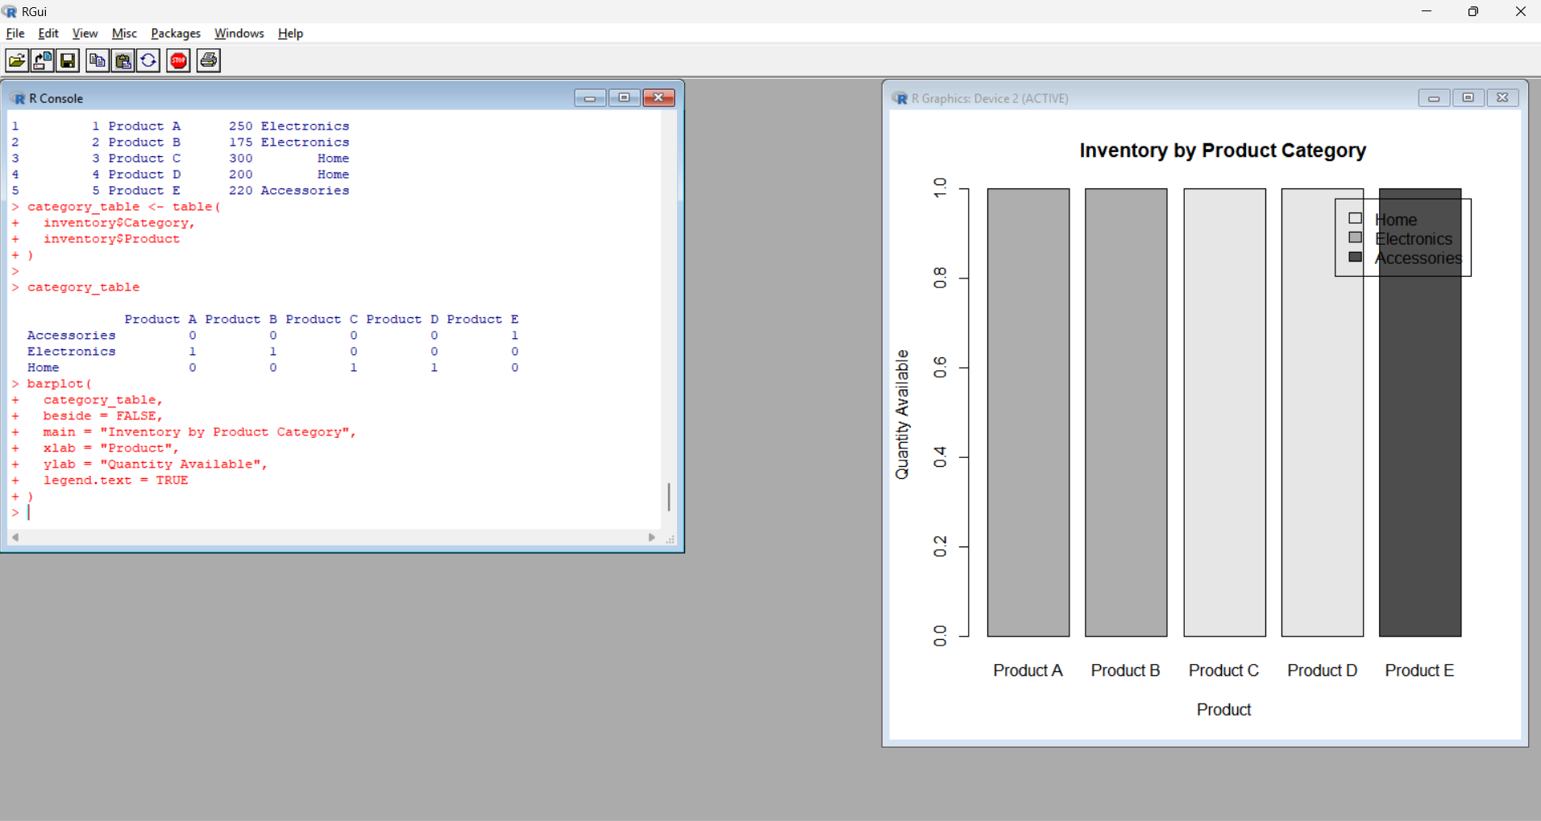
Output 2: Inventory by Product Category
Observation: The stacked bar chart displays the inventory quantities according to product categories. Products A and B belong to Electronics, Products C and D belong to Home, and Product E belongs to Accessories.

PROGRAM 3: Scatter Plot of Price vs Quantity
Develop a scatter plot to explore the relationship between product price and quantity available.
Note: Price is not included in the original dataset, so the following are sample price values.
Product | Price ($) | Quantity
Product A | 500 | 250
Product B | 300 | 175
Product C | 700 | 300
Product D | 450 | 200
Product E | 600 | 220
# Dataset
product <- c("Product A", "Product B", "Product C",
"Product D", "Product E")

sales <- c(250, 175, 300, 200, 220)

price <- c(500, 300, 700, 450, 600)

# Scatter Plot
plot(price, sales,
main = "Product Price vs Quantity Available",
xlab = "Product Price ($)",
ylab = "Quantity Available",
pch = 19,
col = "red")
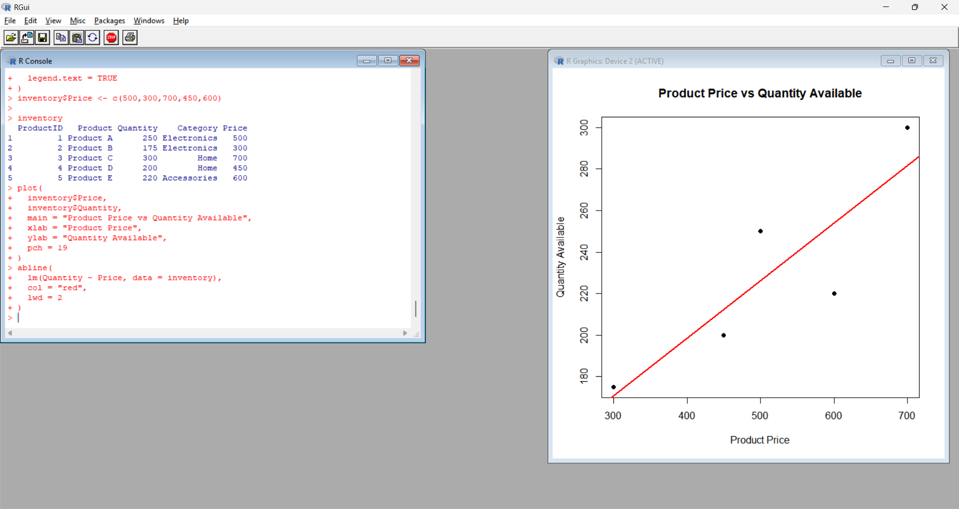
Output 3: Product Price vs Quantity Available Scatter Plot
Insight: The scatter plot shows the relationship between product price and available quantity. The plotted points indicate how the quantity available varies with the product price for the given sample values.
PROGRAM 4: Interactive Product Inventory Dashboard
Build an interactive dashboard combining the product inventory bar chart and stacked bar chart using Tableau.
Dataset for Tableau
Create an Excel file with the following data:
Product ID | Product Name | Quantity Available | Category
1 | Product A | 250 | Electronics
2 | Product B | 175 | Electronics
3 | Product C | 300 | Home
4 | Product D | 200 | Home
5 | Product E | 220 | Accessories
Save the file as:
Product_Inventory.xlsx
Tableau Steps
- Open Tableau.
- Select Microsoft Excel.
- Open Product_Inventory.xlsx.
- Select Sheet 1.
- Drag Product Name to Columns.
- Drag Quantity Available to Rows.
- Select Bar from the Marks card.
- Select Label → Show Mark Labels.
- Rename the sheet Product Inventory.
- Create a new worksheet.
- Drag Product Name to Columns.
- Drag Quantity Available to Rows.
- Drag Category to Color.
- Select Bar to create the stacked bar chart.
- Select Label → Show Mark Labels.
- Rename the sheet Inventory by Category.
- Click New Dashboard.
- Drag Product Inventory into the dashboard.
- Drag Inventory by Category into the dashboard.
- Set the title as Product Inventory Management Dashboard.
- Select Use as Filter to make the dashboard interactive.

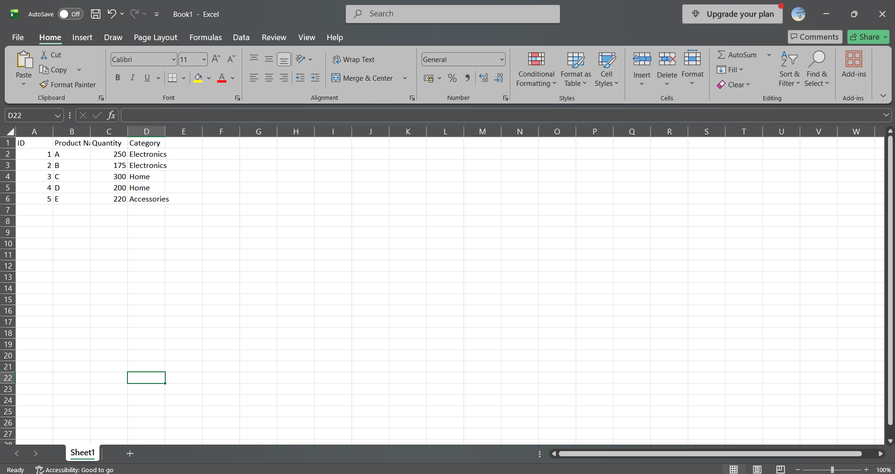
Output 4: Product Inventory Management Dashboard
Observation: The dashboard combines product-wise inventory and category-wise inventory into a single interactive view. It allows users to compare product quantities and analyze inventory distribution across different categories.
Procedure
1. Create the product and quantity vectors in R.
2. Use barplot() to create the product inventory bar chart.
3. Create product categories and use table() and barplot() to generate the stacked bar chart.
4. Create price and quantity vectors and use plot() to generate the scatter plot.
5. Create an Excel file containing product, quantity, and category information.
6. Connect the Excel file to Tableau.
7. Create the product inventory bar chart in Tableau.
8. Create the category-wise stacked bar chart.
9. Combine both charts into an interactive dashboard.
Result
The product inventory data was successfully visualized using bar, stacked bar, and scatter plots. An interactive Tableau dashboard was also created to display product-wise and category-wise inventory information.

